Regarding production order 8903190, the operation 0316

I check the confirmation log and find that the time is below zero

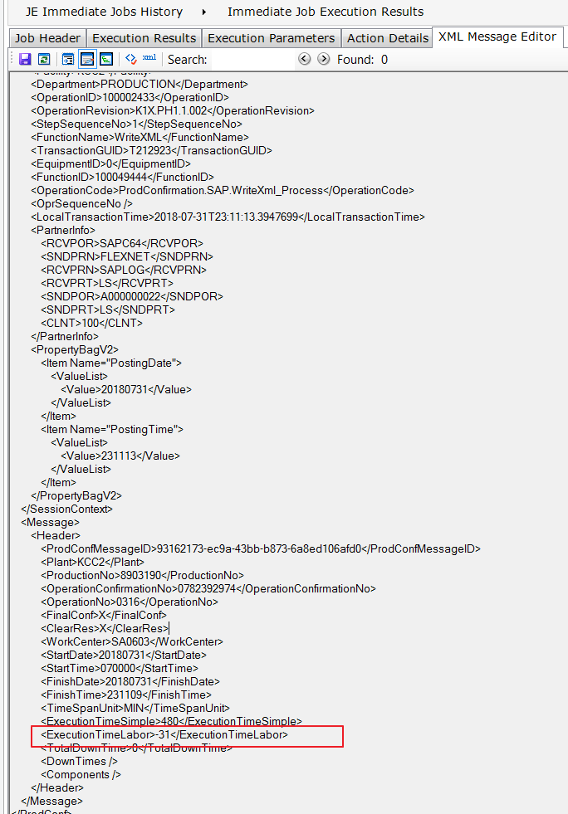

But the progress in POE is

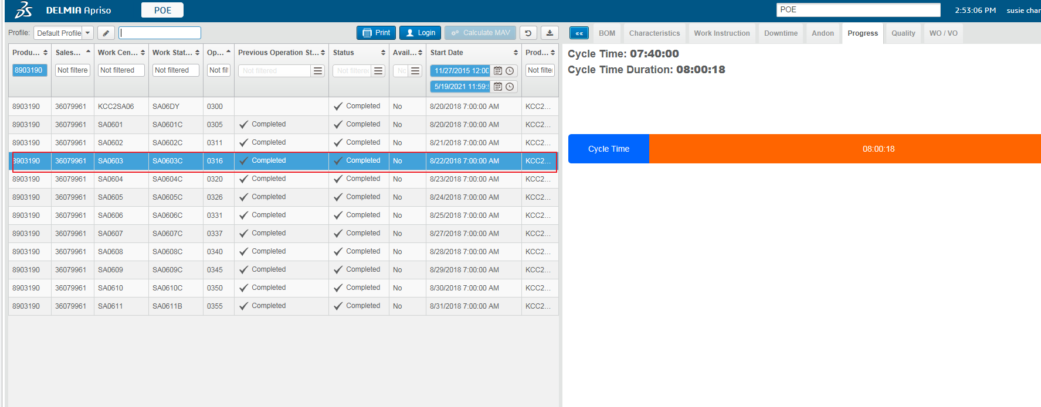

And then the idoc to SAP cause an error



